**Output Description**

1. **Beginning with showing the Game Menu**

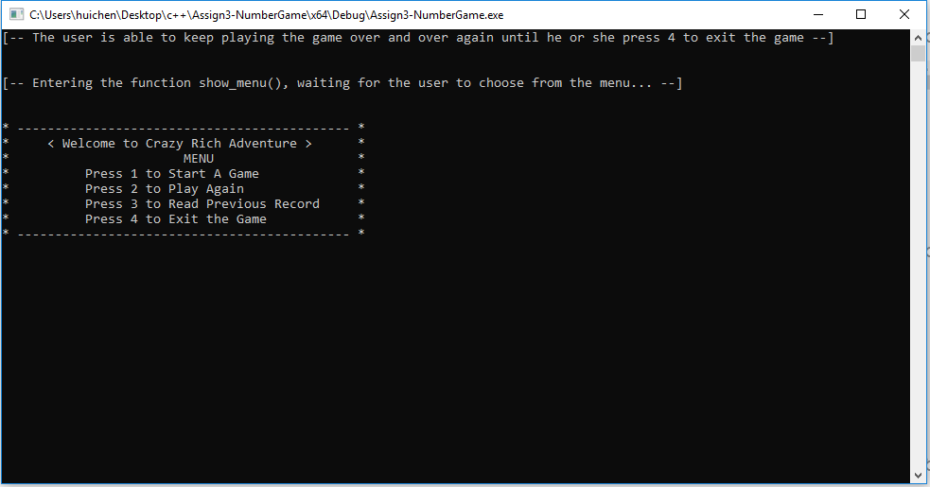

1. **Press 1 from the menu to start a game (the interface for option 2 “play again” is similar to this one)**

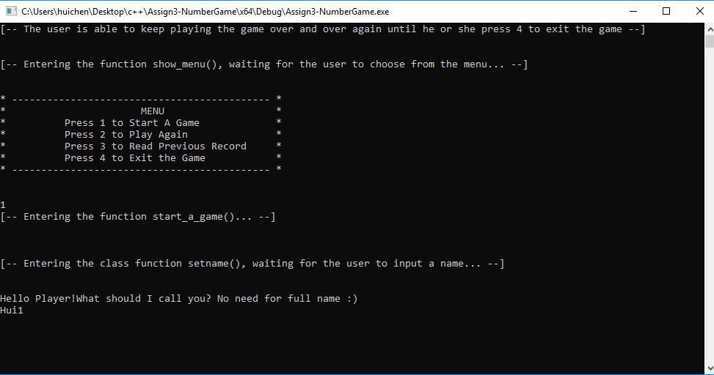

1. **Once the game starts, the program will ask the first player to input a name and how much he or she want to bet on, here is the result for the first player:**

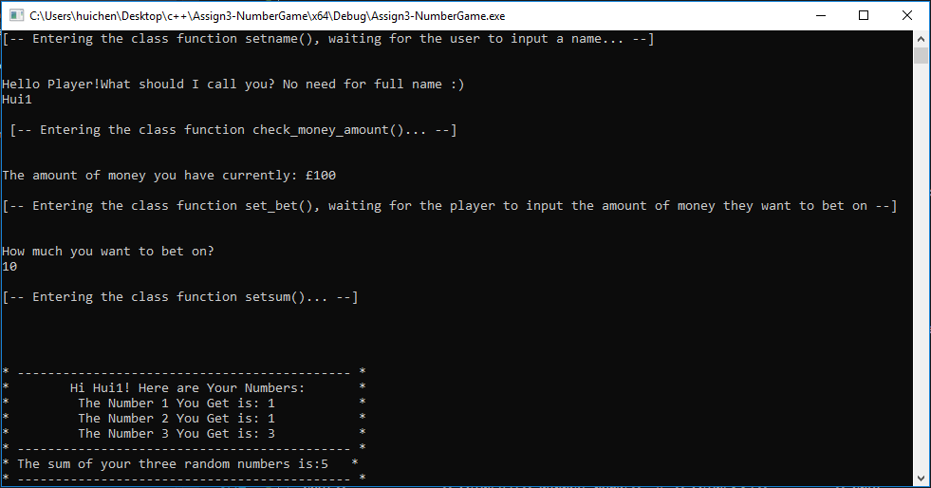

1. **The result for the second player, who firstly attempted to bet more than she has:**

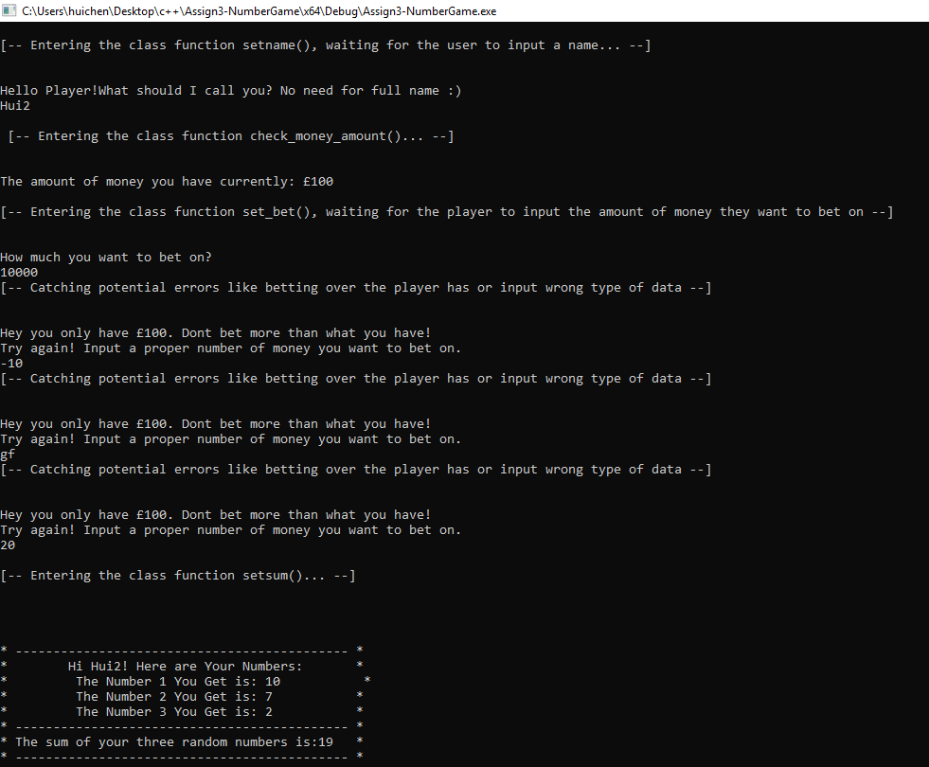

1. **The result for the third player, who has the same sum with the second player, at 19:**

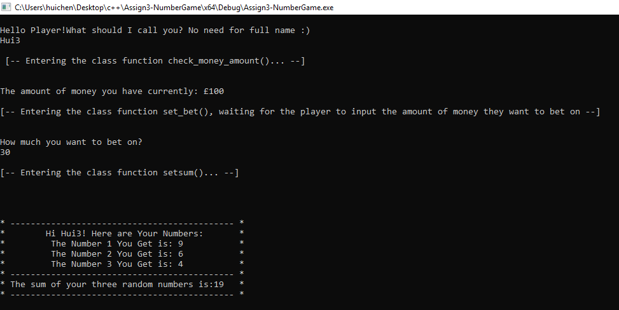

1. **The result for the fourth player:**

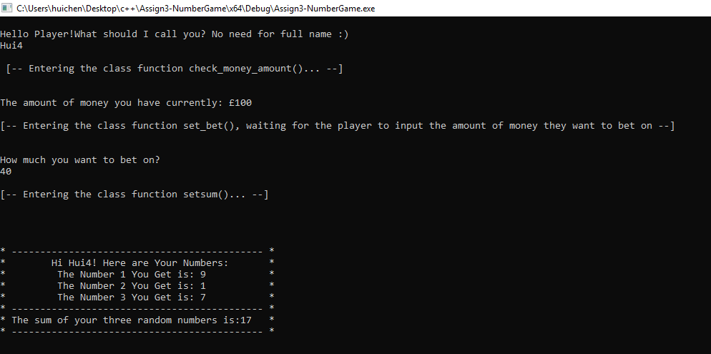

1. **The result for the last player:**

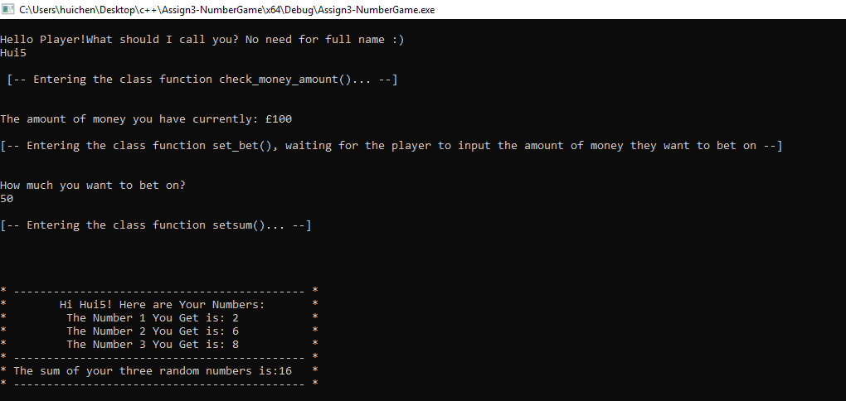

1. **After five players played their rounds, the program starts to identify who is the final winner, and the final winner will have a double amount of money which she or he used to bet. Another players who lost the game will lose the part of the money which they bet. As shown in the screenshot, Hui2 and Hui3 are both winners. Hui2 bet £20 and Hui3 bet £30,so Hui2 now has £100 + (£20 * 2) = £140 in total, and Hui3 has £160 in total:**

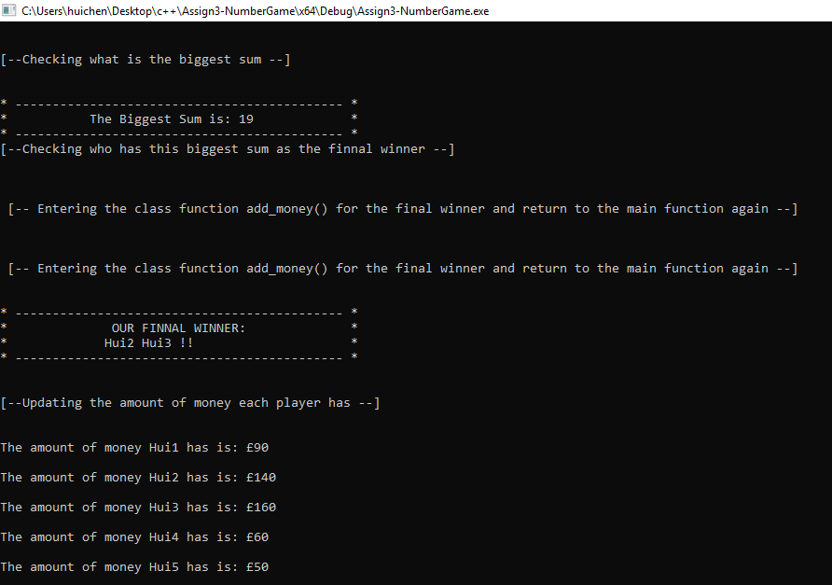

1. **This is the final result where it has only one final winner:**

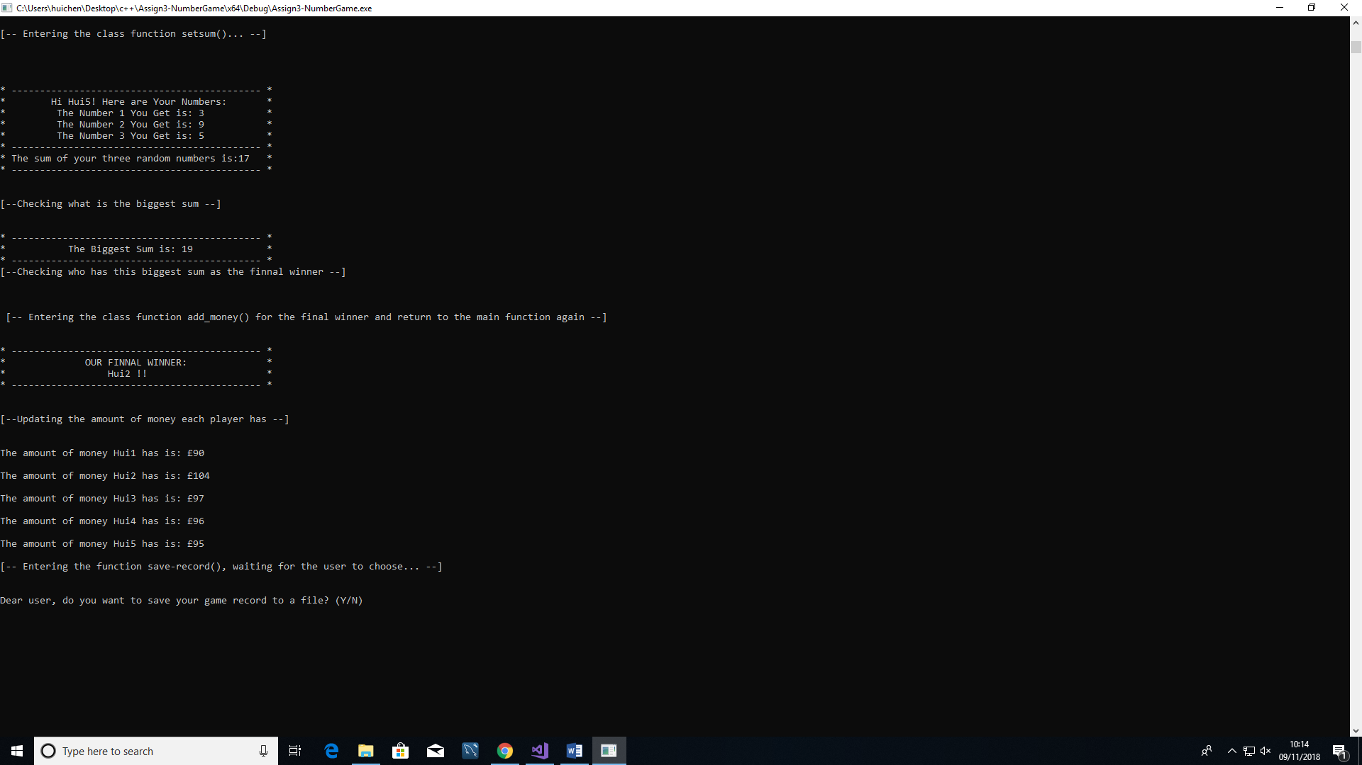

1. **After the game, the user will be provided with the option whether he or she wants to save the game or not, here is the screenshot for saving into a file, the user firstly input wrong type of information so the program kept prompting the user to give a correct input:**

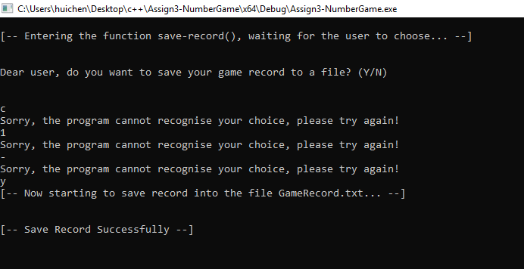

1. **The screenshot for choosing no saving record, and the program restart the whole process by showing the menu again, unless the user press 4 to exit the whole program:**

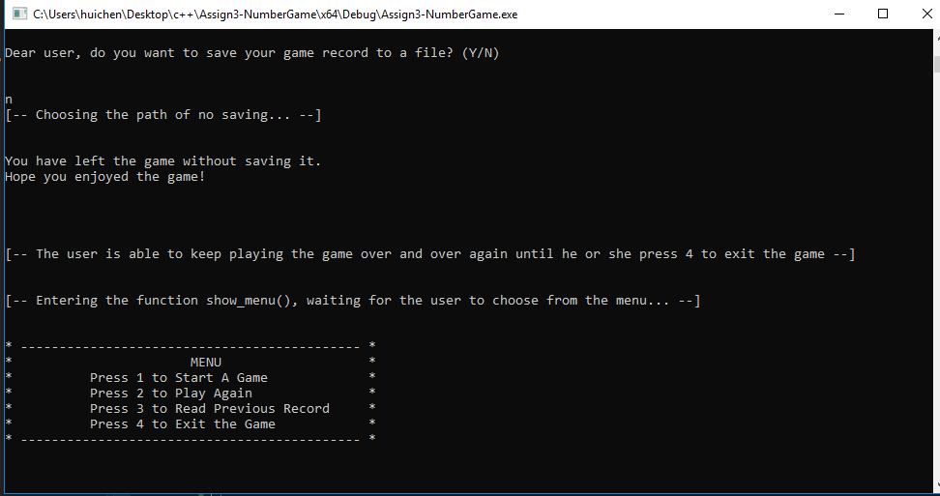

1. **The screen for reading previous game record:**

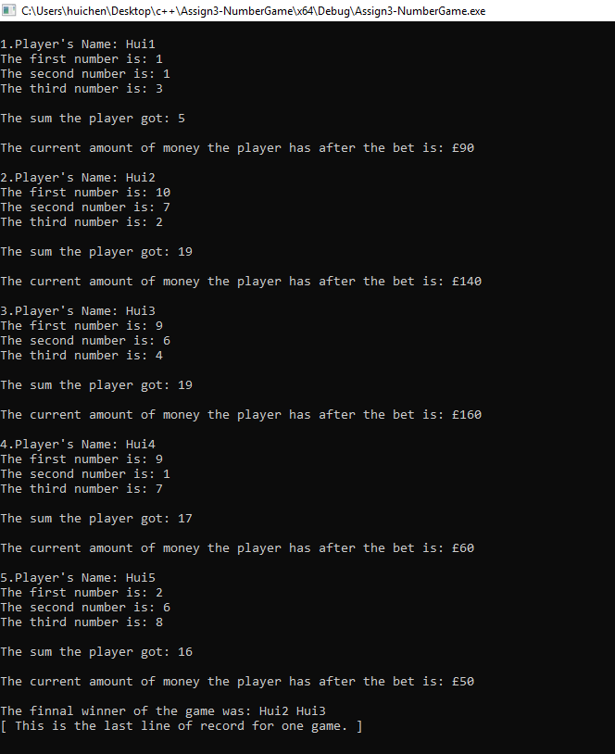

1. **The screen for exiting the game after trying several error input:**

